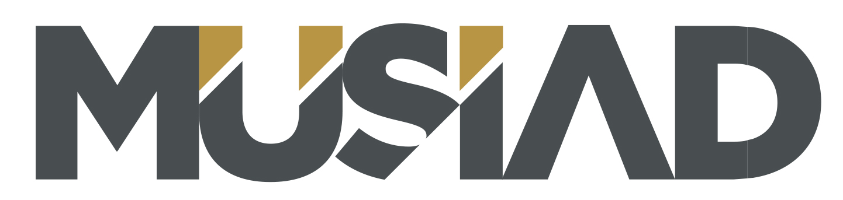
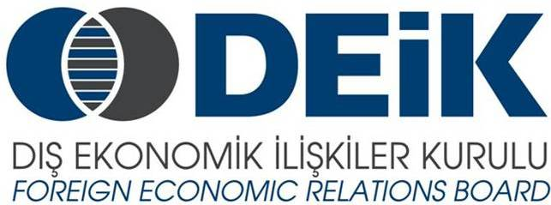
TURKEY-MALTA BUSINESS FORUM
September 30th 2015, Hilton İstanbul Bosphorus

DRAFT AGENDA

30 September 2015 Wednesday
09:00-09:30 Registration
09:30-09:40 Film on Turkish Economy
09:40-10:00 Welcoming Speeches
- Ömer Cihad Vardan, President, DEİK
- Nail Olpak, President, MÜSİAD – Vice Chairman, DEİK

10:00-10:20 Session 1. An invitation to improving business relations between Turkey and Malta
- Anton Borg, Chairman, Malta Chamber of Commerce, Enterprise and Industry

10:20-10:50 Coffee Break
10:50-12:00 Session 2. Business opportunities for Maltese Businessmen in Turkey

Moderator: Halis Ali Çakmak, Co-Chairman, Turkey-Malta Business Council

- Vice Chairman, Yıldırım Holding
- Tourism Sector Representative – TURSAB Association of Turkish Travel Agencies
- Anton Buttigieg – Trade Malta CEO - will be present on the panel to address relevant key issues.
- Other speakers and panel members are still to be confirmed
Questions & Answers

12:00-13:30 Session 3. Malta, a formidable business partner

Presentations followed by Question and Answers.
Moderator: Mark Bencini, Co-Chairman, Malta-Turkey Business Council

- Presentation by Malta Enterprise
- Presentation by Finance Malta
- Presentation by Transport Malta

13.30-14:30 Open Buffet Luncheon

14.30-18:00 B2B Meetings for Networking

